Ideation Phase

Brainstorm & Idea Prioritization Template

|  |  |
| --- | --- |
| Team ID | PNT2002TMID10050 |
| Project Name | Personal Assistance for senior citizens who are self-reliant |
| Maximum Marks | 4 Marks |

**Brainstorm & Idea Prioritization:**

Reference:[https://app.mural.co/invitation/mural/sridharanr2543/1666004422862?sender=uf5509](https://app.mural.co/invitation/mural/sridharanr2543/1666004422862?sender=uf5509b498aa0440833a02996&key=c4d55e0c-ed8d-4c47-93d0-a134a4e64609) [b498aa0440833a02996&key=c4d55e0c-ed8d-4c47-93d0-a134a4e64609](https://app.mural.co/invitation/mural/sridharanr2543/1666004422862?sender=uf5509b498aa0440833a02996&key=c4d55e0c-ed8d-4c47-93d0-a134a4e64609)

**Step-1: Brainstorm, Idea Listing and Grouping**

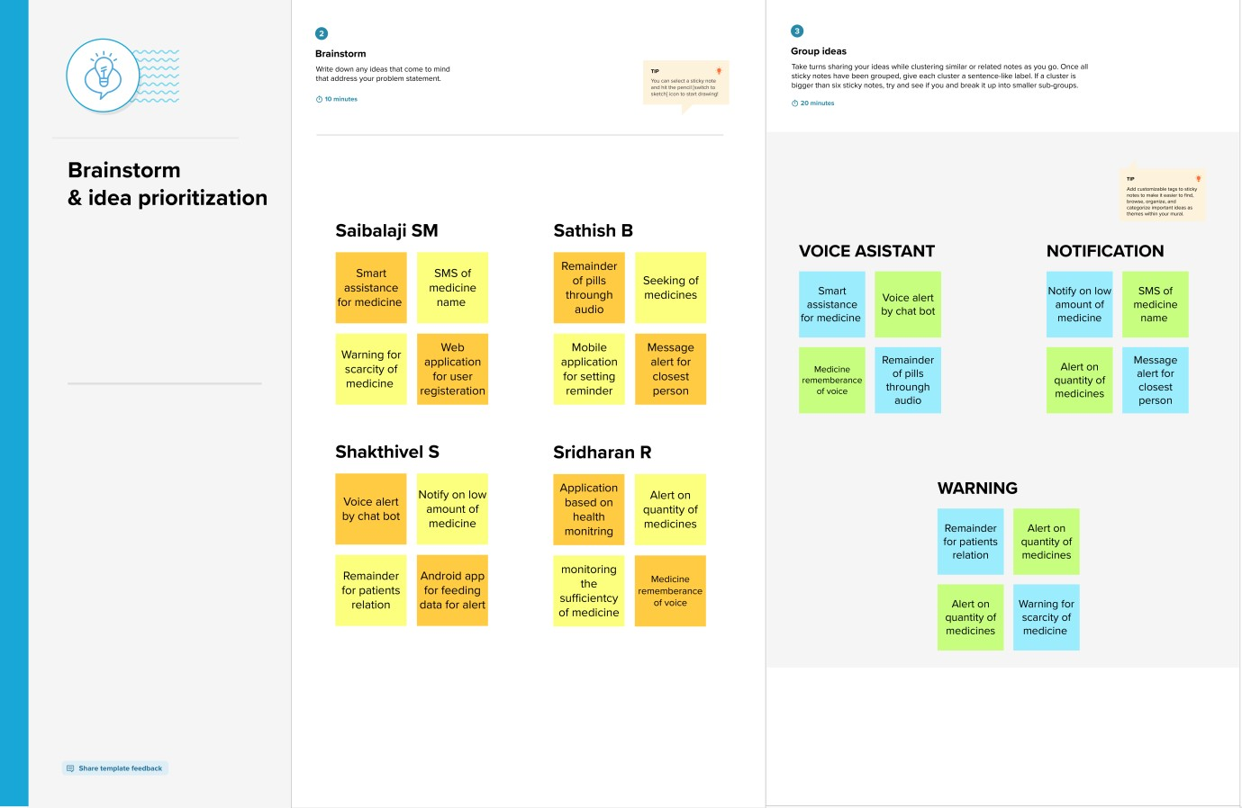

**Step-2: Idea Prioritization**

